BridgeU
Software Requirement Specification

Zhiyi Pan 652115558

Bachelor of Science
Software Engineering Program

Department College of Arts, Media, and
Technology
Chiang Mai University
December 2025
Project Advisor
Asst. Prof. Pattama Longani, Ph.D.

Document  Name | Version | History | Status | Date | Editable | Reviewer
BridgeU-SRS | BridgeU-SRS V.0.1 | Add Chapter 1  • 1.1Purpose and Scope  •1.2User  Character is  • 1.3 Acronyms and Definitions  Add Chapter 2  Progress 1  • Use Case  Diagram  • Use Case  Description | Draft | 06/05/2024 | ZHIYI PAN | Asst.Prof. Pattama Longani, Ph.D.

Table Content
Chapter 1 Introduction 4
1.1 Purpose and Scope 4
1.2 User Characteristics 4
1.3 Acronyms and Definitions 4
Chapter 2 Specification Requirement 7
2.1 Use Case Scenario 7
2.1.1 Feature 1 7
2.1.2 Feature2 9
2.2.3 Feature 3 11
2.2 User Requirement Specification 13
2.3 Use Case Description and Activity Diagram 错误!未定义书签。

Chapter 1 Introduction

1.1 Purpose and Scope
The purpose of the software design development is to present a complete software design of the BridgeU project. This document contains the outline of the software architecture, functions used, and activity diagrams with the user interface for this project. BridgeU aims to eliminate language barriers through AI technology and establish a bilingual mutual assistance ecosystem connecting Chinese students, global students, and local Thai merchants.

1.2 User Characteristics
Users:
- Admin
- Student
- Merchant
Description:

1.3 Acronyms and Definitions
SRS | Software Requirement Specification
URS | User Requirement Specification
UTC | Unit Test Case
STC | System Test Case
UC | Use Case
SRC | Software Requirements Specification
RSS | Really Simple Syndication
JWT | JSON Web Token
AI | Artificial Intelligence
LLM | Large Language Model

Definition
Name | Definition
IEEE | Institute for Electrical and Electronics Engineers. Biggest global interest  group for engineers of different branches and computer scientists.
Plan | A document series of tasks requires meeting an objective, typically  including the associated schedule, budget, resources, organizational  description and work breakdown structure.
Feature | Feature Transformation of input parameters to output parameters based  on a specified algorithm. It describes the functionality of the product in  the language of the product. Used for requirements analysis, design,  coding, testing or maintenance.
Project  Management | The application of knowledge, skills, tools, and techniques to project  activities in order to meet or exceed stakeholder needs and expectations  from a project.
Project Plan | A formal, approved document used to guide both project execution and  project control. The primary uses of the project plan are to document  planning assumptions and the decision, to facilitate communication  among stakeholders, and to document approved scope, cost, and  schedule baseline.
Risk | An uncertain event or condition that, if it occurs, has a positive or  negative effect on a project’s objectives. It is a function of the  probability of occurrence of a given threat’s occurrence.
Risk  Management | The systematic application of management policies, procedures and  practices to the tasks of identifying, analyzing, evaluating, treating and  monitoring risk.
System Testing | Testing conducted on a complete and integrated system for evaluate the  system’s compliance with its specified requirements.
Unit Test | A test of individual programs or modules in order to remove a design or  programming errors.
Traceability | The ability to trace the history, application or location of an item or  activity, or work products or activities, by means of recorded  identification. The establishment and maintenance of relationships  between such items. Horizontal traceability describes the relationship  between work products of the same type (e.g. Customer requirements).  Vertical traceability describes the relationship between work products,  which build or derived from each other (e.g., from customer  requirements to qualification test cases). Bidirectional traceability  allows to directly following relationships in both directions.
Use Case | A use case is a description of a specific interaction between a system  and its users to accomplish a particular goal or task. It outlines the  sequence of steps or actions that a user performs in the system and  describes the system's responses to those actions. Use cases help to  identify and define the functional requirements of a system from the  perspective of its users.
Activity Diagram | Activity diagram is another important behavioral diagram in UML  diagram to describe dynamic aspects of the system. Activity diagram is  essentially an advanced version of flow chart that modeling the flow  from one activity to another activity.

Chapter 2 Specification Requirement

2.1 Use Case Scenario

2.1.1 Feature 1

2.1.1.1 Actor

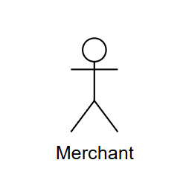

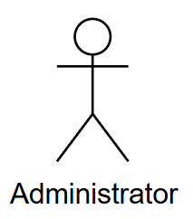

2.1.1.2 Use Case Diagram
Feature 1: Automated Information Aggregation Bot
This use case diagram describes the core interactive functions of the automated information aggregation robot. Users (including international students and businesses), as the main participants, can access the system to browse the Daily Briefing. During the browsing process, users can choose to extend operations such as View News Details, Search News, Filter News and Jump to the original text. The Administrator is responsible for managing or manually triggering crawler tasks in the background (Manage/Trigger Crawling) to ensure the real-time nature of the data.

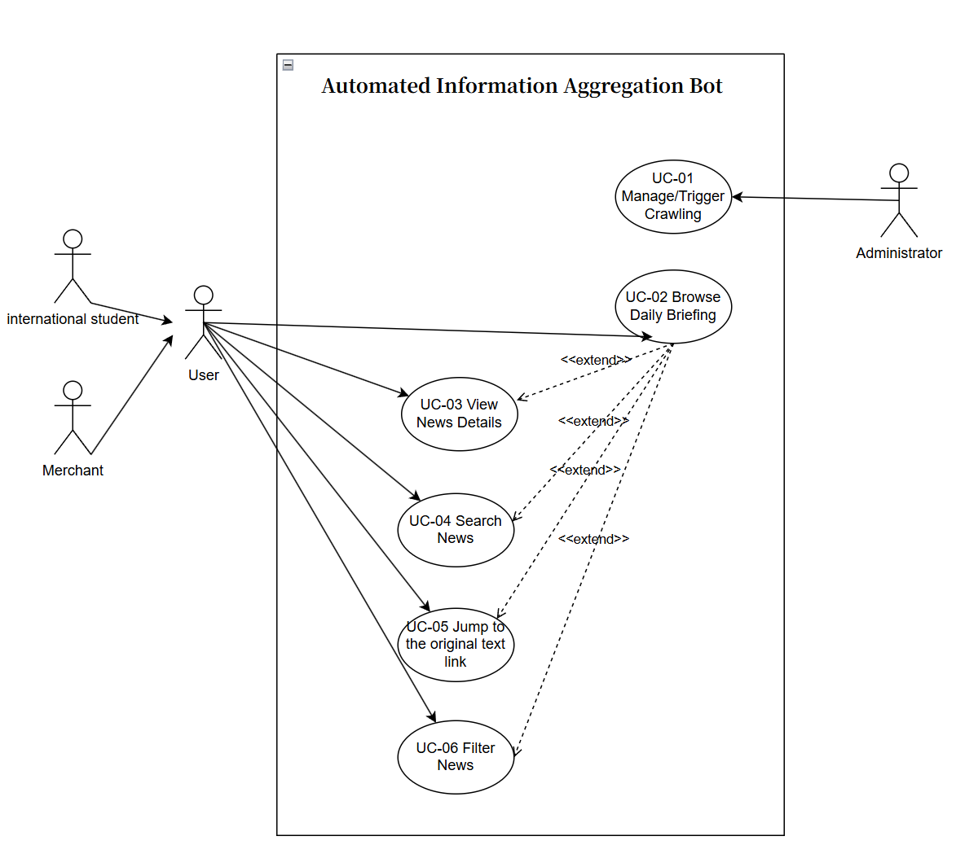

2.1.2 Feature2

2.1.2.1 Actor



2.1.2.2 Use Case Diagram
Feature 2: AI Intelligent Translation Engine
When Student/ Merchant submits or edits posts (UC-07), it forces <<include>> to invoke the UC-08 automatic translation engine to generate bilingual copies in Chinese and English. Post details (UC-11), daily briefings (UC-09), or comments (UC-12) will all reuse the translation of UC-08 through <<include>>. The function of UC-10 interface language switching for reading scenarios <<extend>> : Users can switch between Chinese and English views, and the system displays the corresponding translation content according to the selected language, achieving a full-chain cross-language experience of "publishing is bilingual, reading can be switched, and comments are also bidirectional".
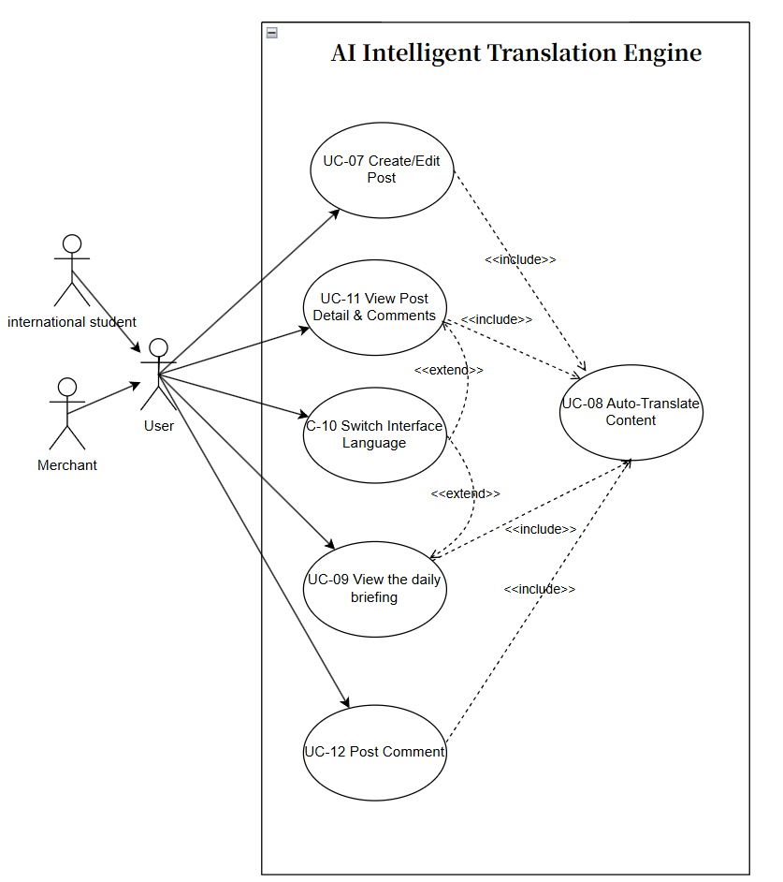

2.2.3 Feature 3

2.2.3.1 Actor





2.2.3.2 Use Case Diagram
Feature 3: AI-Powered Hybrid Content Moderation (AI + Human Loop)
When Student/ Merchant submits content, it triggers the UC-14 AI real-time screening: the AI automatically makes decisions based on the confidence level - if the score is less than 60, it directly rejects and provides the reason. A score of 60≤score<80 is marked as pending review. A score of 80 or above will automatically pass. The content to be reviewed enters the UC-17 review list from the administrator's perspective, and is manually reviewed by UC-15. The final approval/rejection is made through UC-18 (the reasons for rejection need to be filled in and fed back to the user). The rejected content will present the reasons for rejection to users on UC-16. Users can modify it and resubmit it, entering the same review process again to achieve a closed loop of "AI efficient filtering + manual fallback decision-making + users checking the reasons and resubmitting".
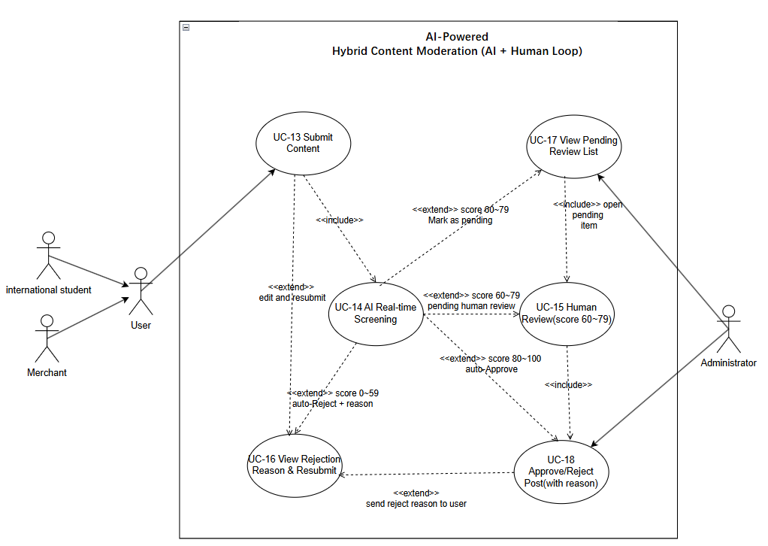

2.2 User Requirement Specification
Feature1:
URS-01: The Administrator can manage or manually trigger the crawling task to ensure data real-time updates.
URS-02: The User (International Student/Merchant) can browse the Daily Briefing to view the latest news summaries.
URS-03: The User can view news details.
URS-04: The User can search for specific news information within the Daily Briefing.
URS-05: The User can jump to the original text link to read the full report from the source website when the user sees the News.
URS-06: The User can filter news based on specific criteria (e.g., source, date) while browsing.
Feature2:
URS-07: The User (Student/Merchant) can create or edit posts in their preferred language (Chinese, English).
URS-08: When users create posts, edit posts, comment on posts, view daily briefings, comments, and post details, the system will automatically translate the content into both Chinese and English.
URS-09: Users can view the daily briefings on the website.
URS-10: The User can switch the interface language (ZH/EN) while browsing to view content in the selected language.
URS-11: The User can view post details and associated comments when he click the post. (
URS-12: The User can post comments to interact with other users, which will be automatically translated by the system.
Feature3:
URS-13: The User (Student/Merchant) can submit content, which triggers an automatic AI Real-time Screening process.
URS-14: The User receives immediate processing results based on the AI confidence score: Auto-Approve (score 80-100), Pending Human Review (score 60-79), or Auto-Reject (score 0-59).
URS-15: The User can view the specific rejection reason and edit the post to resubmit it if the content is rejected.
URS-16: The Administrator can access the "Pending Review List" to view items that scored between 60 and 79 and require human verification.
URS-17: The Administrator can perform a human review on pending posts and execute an approve or reject operation.
URS-18: The Administrator must provide a specific rejection reason when rejecting a post, which is then sent to the user.

